31.47: a) 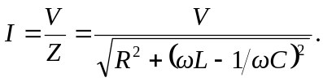
b) 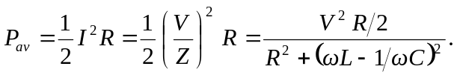
c) The average power and the current amplitude are both greatest when the denominator is smallest, which occurs for 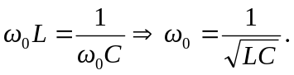
d) 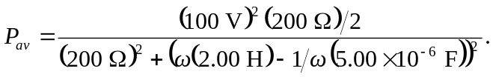
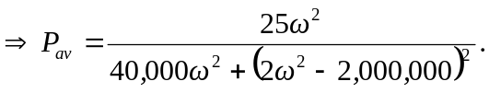

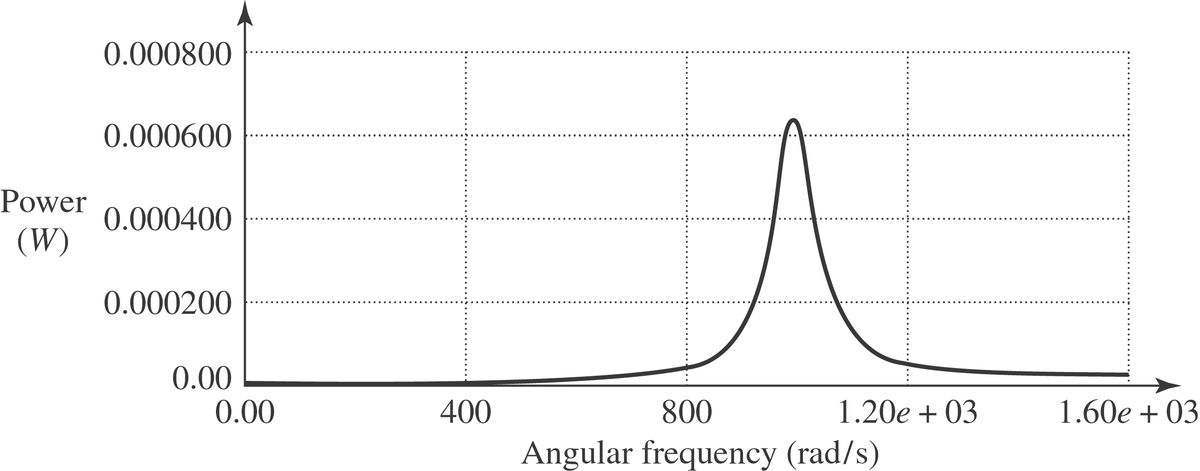

Note that as the angular frequency goes to zero, the power and current are zero, just as they are when the angular frequency goes to infinity. This graph exhibits the same strongly peaked nature as the light red curve in Fig. (31.15).

